**Lab - Disable the Internet Explorer Enhanced Security Configuration (IE ESC)**

**Overview**

In this lab, we learn how to disable the Internet Explorer Enhanced Security Configuration (IE ESC) in Windows Server 2012. Microsoft calls this a security enhancement, but most agree it’s more of an annoyance.

[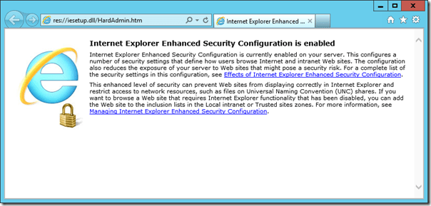](https://4sysops.com/wp-content/uploads/2012/05/Internet-Explorer-Enhanced-Security-Configuration-is-enabled.png)

*Internet Explorer Enhanced Security Configuration is enabled*

If Server Manager does not launch, start by launching Server Manager from either the Start Screen or the Desktop.

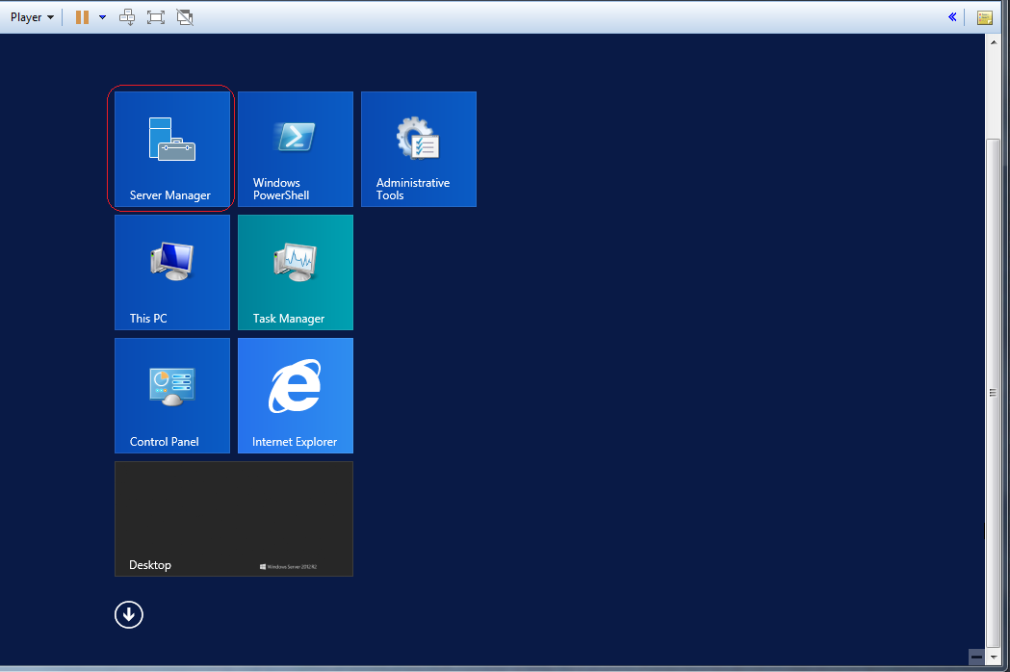

*Server Manager in Windows Server 2012*

In the Server Manager Dashboard, click on Local Server on the left side.

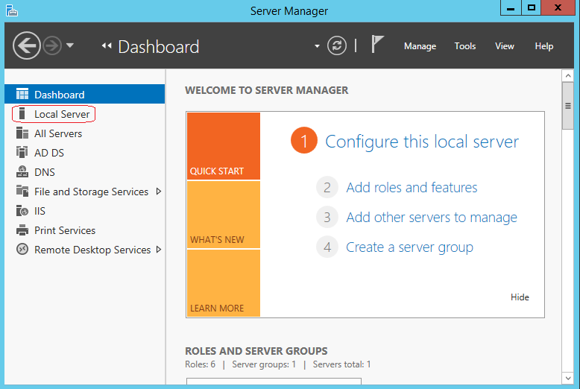

Move the slider under properties all the way to the right.

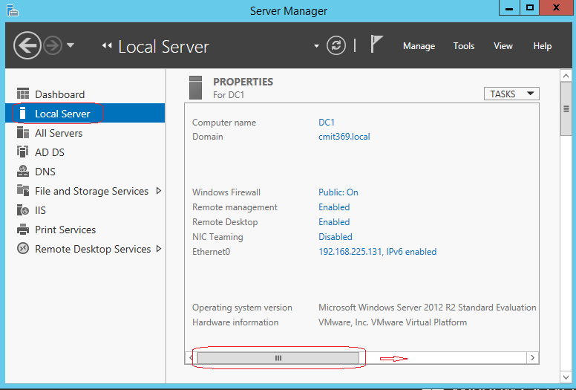

*Windows Server 2012 IE Enhanced Security Configuration*

Find the properties entry for IE Enhanced Security Configuration. X2 click where it says On.

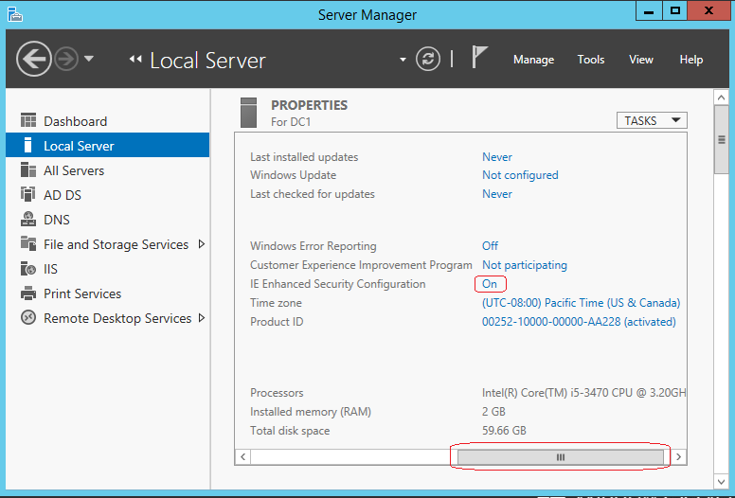

Select the Off button to disable this feature.

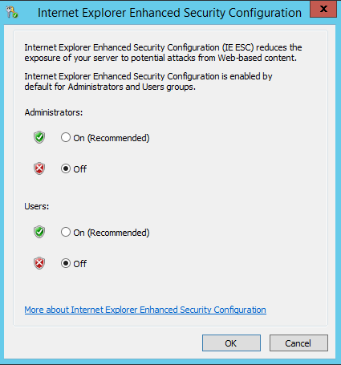

*Disable Internet Explorer Enhanced Security Configuration for Administrators or Users*

Click the Refresh button at the top of the Server Manager, and the IE Enhanced Security Configuration should now show as ‘Off.’

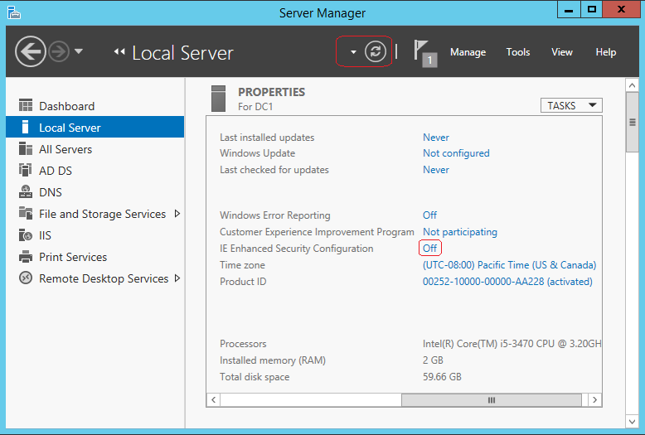

Disable Internet Explorer Enhanced Security Configuration is off

**Should****you turn off IE Enhanced Security Configuration?**

If you’ve ever tried to visit a website from IE on a Windows Server with IE ESC enabled, you know It’s an effort in futility. Security is something we can all get behind but it there has to be a need. No one recommends using a browser on a production server or domain controller to browse the Internet but for testing and evaluation, training labs or non-production environments, this feature becomes more of a hindrance than anything else.

If the target platform is a concern, consider using the Core version of Server 2012 and removing all GUI features including IE.

End of the lab!